Bluetooth Trouble shooting

- Initialize personal data ( in order to delete old remaining data including massage data which may affect something.)
Touch “Info” ➔ “Settings” ➔ “Delete Personal Data” ➔ “Delete” ➔ “Yes”

2. DEACTIVATE the “Message function”
1) On the Message screen, touch “Settings” .
2) On the Setting screen, touch “Off” of “ Auto Message Transfer ”.
3) On the Setting screen, touch “Off” of “ New Message Pop-up ”.

3. Note: Please clear all Bluetooth pair device name (CAR MULTIMEDIA) in customer's phone.
During setting of mobile-phone, it might ask user for “Is it OK to transfer messages?
In such cases, please select “No”.
As per below picture instruction.
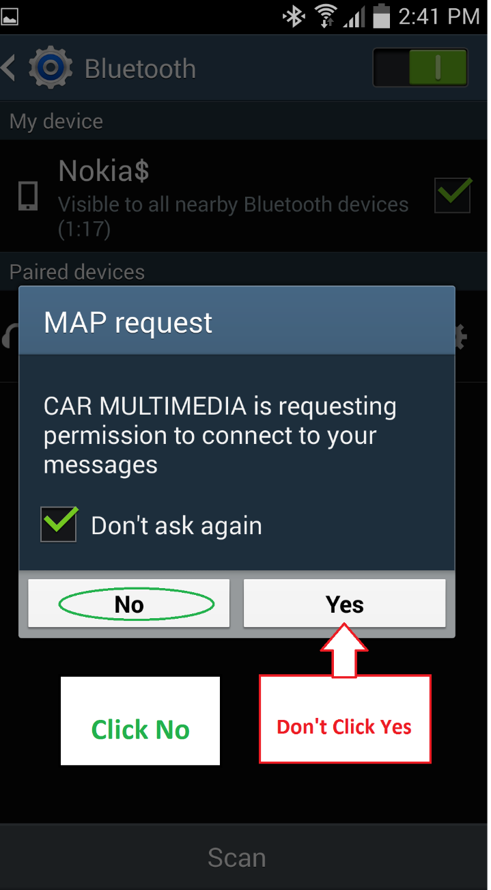
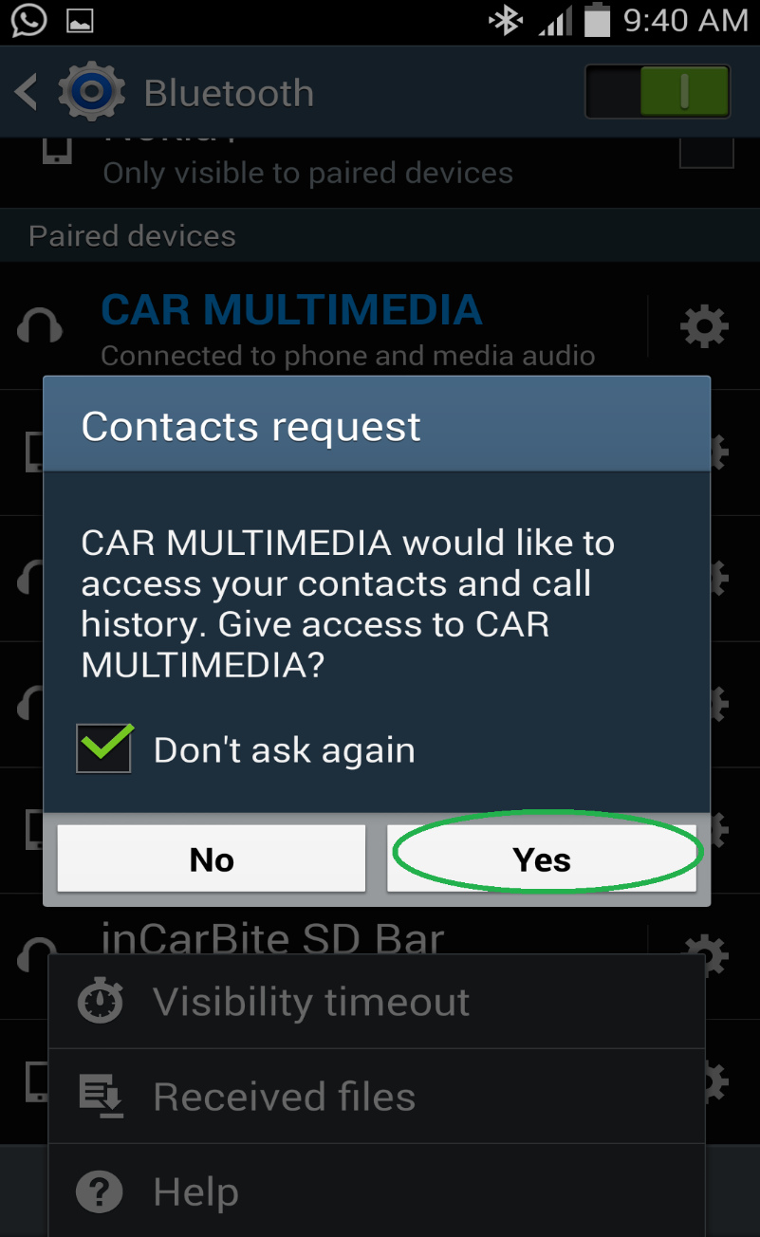
Click Yes

