Parts
Volvo V70 S80 S60 XC90 2.4 Bosch MAF mas air flow meter Sensor 9202199 - £10.00
K&N cone 76mm filter £23.00
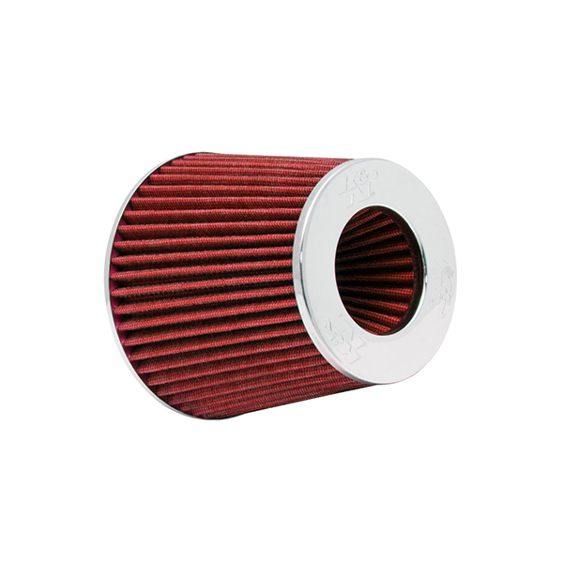
Total: £33.00
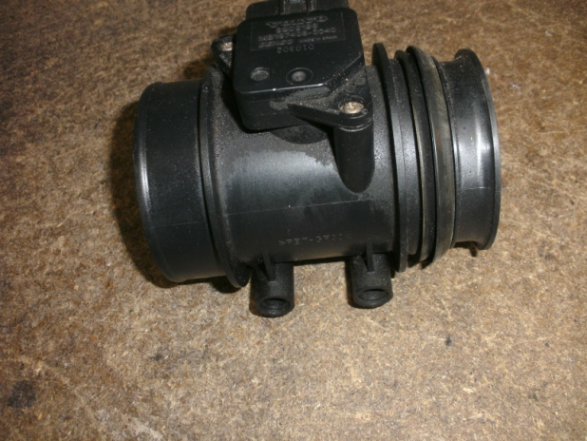

- Disconnected pipe and MAF Sensor (did not unplug it).
- Removed Mazda Air box top and filter
- Connected Volvo MAF housing follow arrow on side for direction to original Mazda pipe
- Connected K&N filter to other end of MAF housing
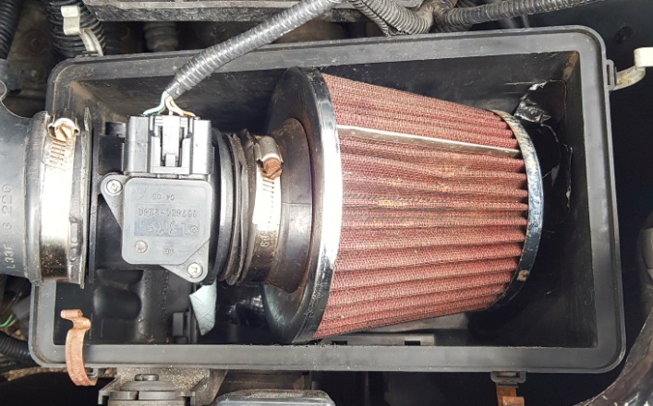
- Installed Mazda MAF sensor (direct fit)

This took 20 minutes to complete. Used WD40 on the pipe end of Volvo MAF housing as it was a tight fit. I have driven the car 200 miles before putting this out in public and had no issues at all.
Seems to pick up better and has a wonderful induction sound.

